TEST SUITES

Step 1: Create a new Test Suite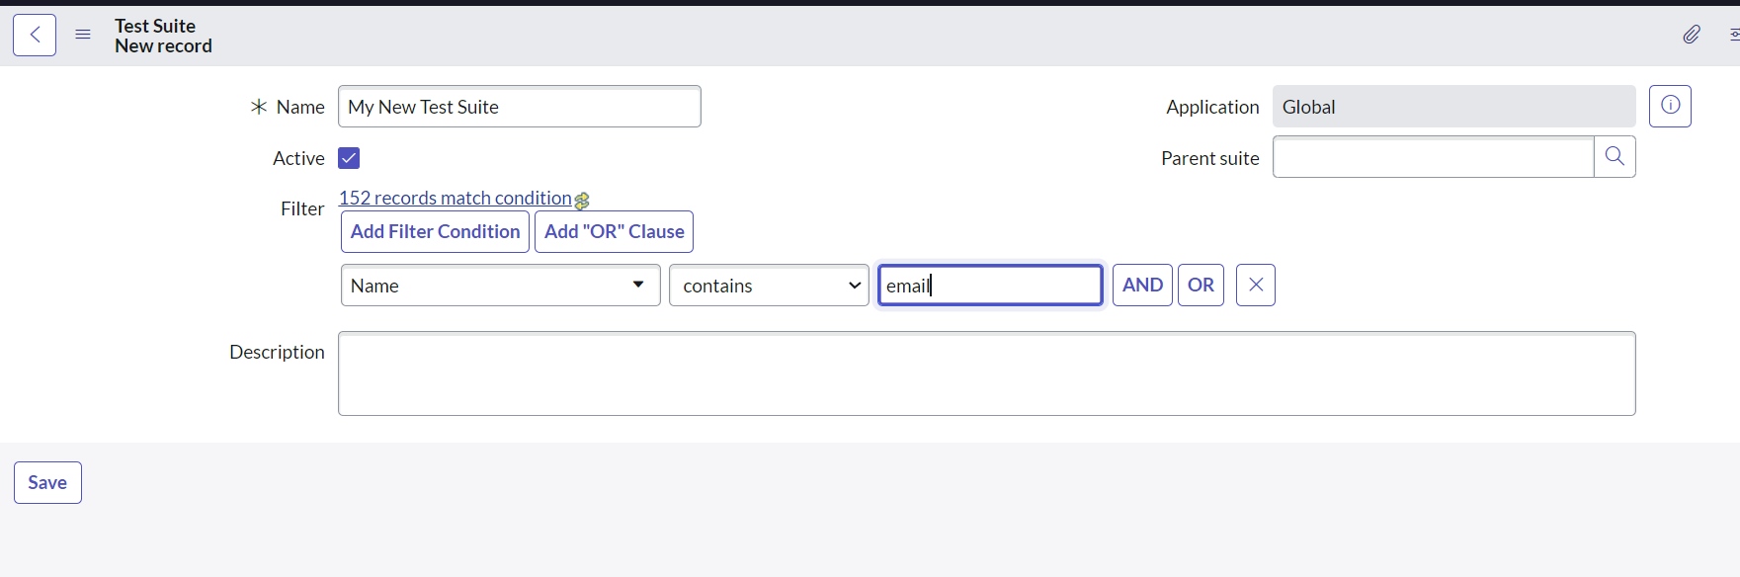

Step 2: Add Test Suites Tests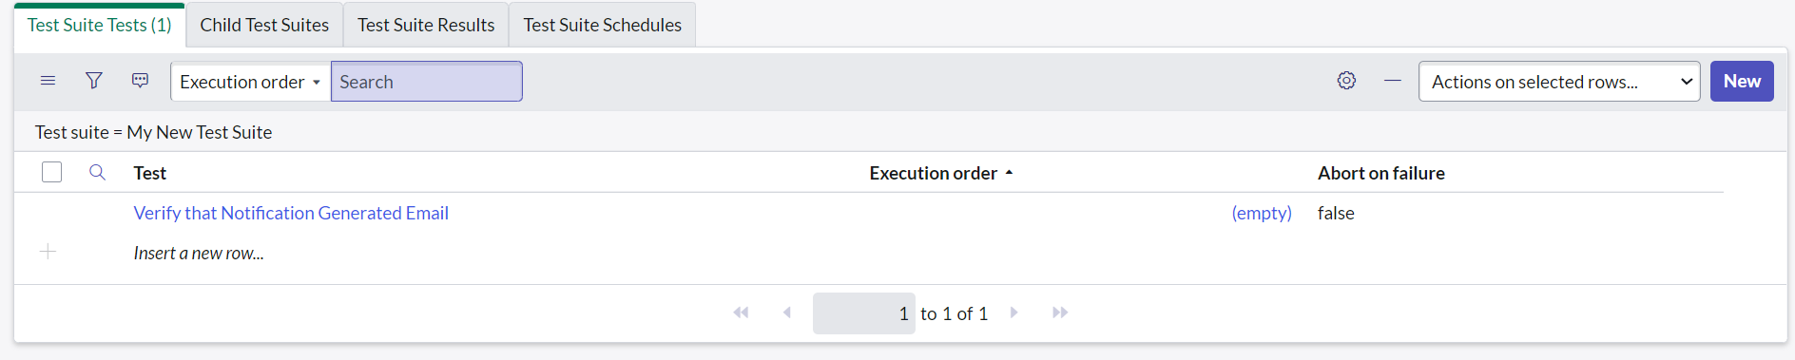

Step 3: Add Child Test Suite

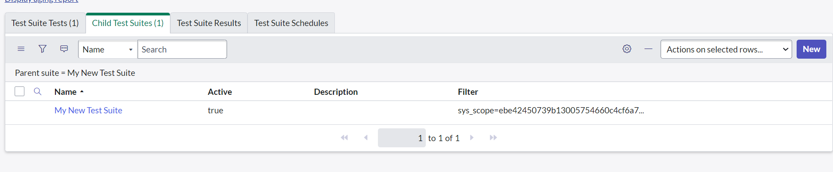

Step 4: Save and Run the Test Suite

